Force - 02
CLASS 09 - SCIENCE

 | Section A
1 | State True or False:  - The firstlaw of motion states that the rate of change of momentum of an object is proportional to the applied unbalanced force in the direction of the force.  - Heavy objects have lighterinertia than lighter objects.  - Thequantityofmotionina body dependsonthe product of massandvelocityof thebody termed as momentum.  - Balanced forces cannot change the state of rest or of uniform motion of a body.  - A body continues to be in a state of rest or in a state of uniform motion along a straight line unless acted upon by an external unbalanced force.  - As the sailor jumps forward out of a rowing boat, the force on the boat moves it backward.  - All objects resist a change in their state of motion.  - A force can change the speed of a moving body.  - While catching a fast - moving cricket ball, a fielder in the ground gradually pulls his hands backward.  - A force can move a stationary body.  - The momentum of a body at motionis zero.  - Newton’s ThirdLaw of Motion states that the action and reaction forces act on two different bodies and never cancel each other.  - When a motorcar makes a sharp turn at a high speed, we tend to get thrown to one side due to the law of inertia.  - The SI unit of workis kg ms$​^{−2}$ .  - The SI unit of acceleration iskg.  - One unit of force is defined as the amount that produces an acceleration of 1 ms$​^{−2}$ on an object of 1 kg mass. | [16]
 | Section B
2 | Fill in the blanks:  - Iftheresultantofalltheforcesactingonabodyisnotzero,thentheforces arecalled ________ forces.  - ________ are worn to prevent such accidents as they exert a force on our body to make the forwardmotion slower.  - ________ forces cannot produce motion in a stationary body or stop a moving body.  - The SI unit of mass is ________.  - The ________ of a body is defined as the product of its mass (m) and velocity (v) and has the same direction as that of the velocity.  - When a gun is fired, it exerts a ________ force on the bullet.  - The football moving on the ground stops after some time due to force of ________ of ground.  - If the resultant of all the forces acting on a body is zero, then the forces are called ________ forces.  - ________ forces can change the state of rest or of uniform motion of a body.  - The ________ law of motion is also known as the law of inertia.  - Force is a ________ quantity.  - The symbol of unit of force is ________.  - The two ________ forces are also known as action and reaction forces.  - The tendency of undisturbed objects to stay at rest or to keep moving with the same velocity is called ________.  - Mass is a measure of ________ of a body.  - Momentum has both magnitudes as well as direction; hence, it is a ________ quantity.  - Newton’s ________ law of motion states that the action and reaction forces act on two different bodies and never cancel each other.  - ________ is that property of the body due to which it resists a change in its state of rest or of uniform motion.  - Momentum of a body at rest is ________. | [19]
 | Section C
3 | Match the following Column A with Column B: 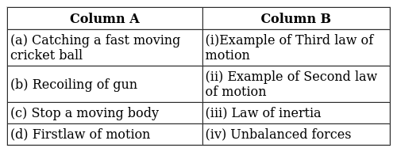 | [2]
4 | Match the following Column A with Column B regarding the effects of force: 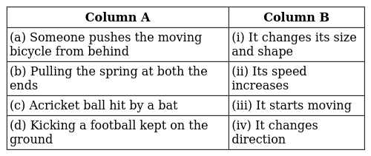 | [2]
5 | Match the following with column I and column II: 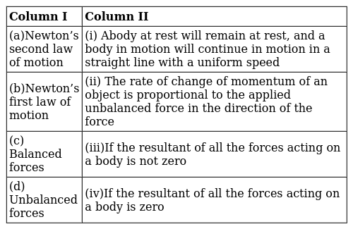 | [2]
6 | Match the following column I with column II: 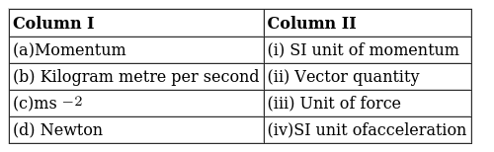 | [2]
7 | Match the following Column A with Column B: 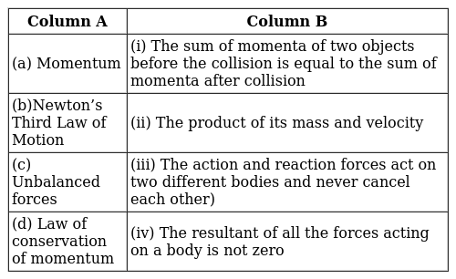 | [2]
8 | Match the following column I with column II: 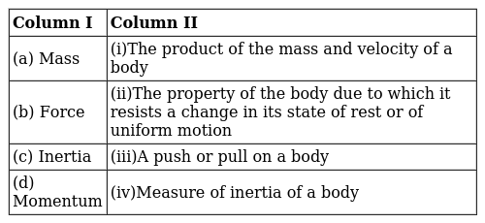 | [2]
9 | Match the following Column A with Column B: 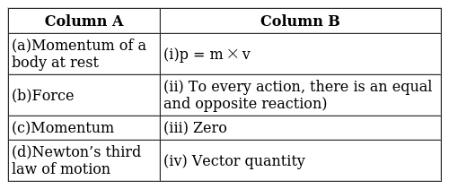 | [2]
10 | Match the following column I with column II: 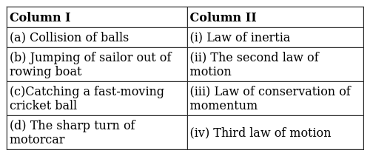 | [2]
 | Section D
11 | Match the following with correct response. 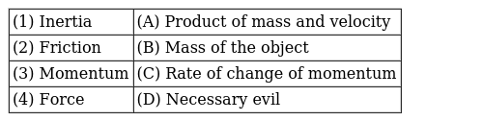  a) 1 - C, 2 - B, 3 - D, 4 - A  b) 1 - B, 2 - D, 3 - A, 4 - C  c) 1 - D, 2 - A, 3 - C, 4 - B  d) 1 - A, 2 - C, 3 - B, 4 - D | [1]
12 | Match the following with the correct response. 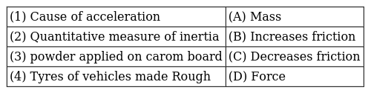  a) 1 - D, 2 - A, 3 - C, 4 - B  b) 1 - C, 2 - B, 3 - D, 4 - A  c) 1 - B, 2 - D, 3 - A, 4 - C  d) 1 - A, 2 - C, 3 - B, 4 - D | [1]
13 | Match the following with the correct response : 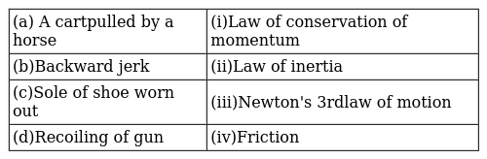  a) (a) - (iv), (b) - (i),(c) - (iii), (d) - (ii)  b) (a) - (i), (b) - (iii),(c) - (ii), (d) - (iv)  c) (a) - (iii), (b) - (ii),(c) - (iv), (d) - (i)  d) (a) - (ii), (b) - (iv),(c) - (i), (d) - (iii) | [1]
14 | Match the following with the correct response. 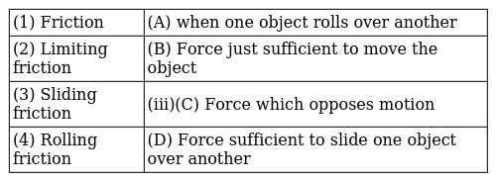  a) 1 - A, 2 - C, 3 - B, 4 - D  b) 1 - C, 2 - B, 3 - D, 4 - A  c) 1 - B, 2 - D, 3 - A, 4 - C  d) 1 - D, 2 - A, 3 - C, 4 - B | [1]
15 | Match the following with correct response. 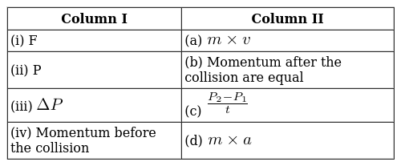  a) (i) - (d), (ii) - (a), (iii) - (c), (iv) - (b)  b) (i) - (c), (ii) - (b), (iii) - (d), (iv) - (a)  c) (i) - (b), (ii) - (d), (iii) - (a), (iv) - (c)  d) (i) - (a), (ii) - (c), (iii) - (b), (iv) - (d) | [1]
16 | Match the following with correct response. 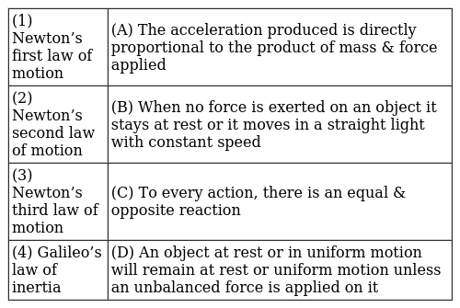  a) 1 - A, 2 - C, 3 - B, 4 - D  b) 1 - D, 2 - A, 3 - C, 4 - B  c) 1 - B, 2 - D, 3 - A, 4 - C  d) 1 - C, 2 - B, 3 - D, 4 - A | [1]
17 | Match the following with correct response. 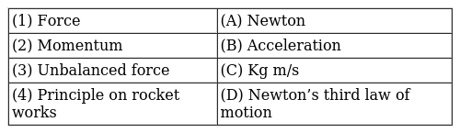  a) 1 - D, 2 - A, 3 - C, 4 - B  b) 1 - B, 2 - D, 3 - A, 4 - C  c) 1 - A, 2 - C, 3 - B, 4 - D  d) 1 - C, 2 - B, 3 - D, 4 - A | [1]
18 | Match the following with the correct response. 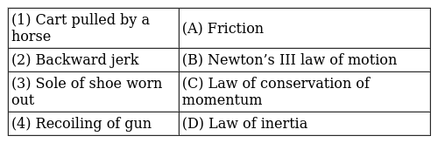  a) 1 - D, 2 - A, 3 - C, 4 - B  b) 1 - B, 2 - D, 3 - A, 4 - C  c) 1 - A, 2 - C, 3 - B, 4 - D  d) 1 - C, 2 - B, 3 - D, 4 - A | [1]
19 | Match the following with the correct response : 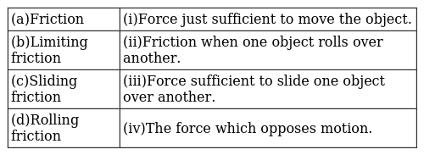  a) (a) - (i), (b) - (iii),(c) - (ii), (d) - (iv)  b) (a) - (ii), (b) - (iv),(c) - (i), (d) - (iii)  c) (a) - (iii), (b) - (ii),(c) - (iv), (d) - (i)  d) (a) - (iv), (b) - (i),(c) - (iii), (d) - (ii) | [1]
20 | Match the following with the correct response: 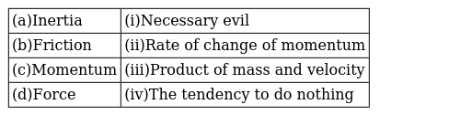  a) (a) - (ii), (b) - (iv),(c) - (i), (d) - (iii)  b) (a) - (iii), (b) - (ii),(c) - (iv), (d) - (i)  c) (a) - (i), (b) - (iii),(c) - (ii), (d) - (iv)  d) (a) - (iv), (b) - (i),(c) - (iii), (d) - (ii) | [1]
21 | Match the following with correct response. 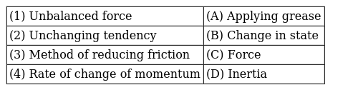  a) 1 - C, 2 - B, 3 - D, 4 - A  b) 1 - B, 2 - D, 3 - A, 4 - C  c) 1 - D, 2 - A, 3 - C, 4 - B  d) 1 - A, 2 - C, 3 - B, 4 - D | [1]
22 | Match the following with the correct response. 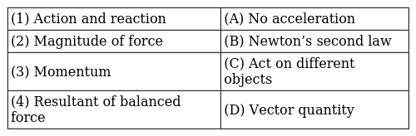  a) 1 - C, 2 - B, 3 - D, 4 - A  b) 1 - B, 2 - D, 3 - A, 4 - C  c) 1 - A, 2 - C, 3 - B, 4 - D  d) 1 - D, 2 - A, 3 - C, 4 - B | [1]
23 | Match the following with the correct response : 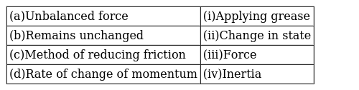  a) (a) - (i), (b) - (iii), (c) - (ii), (d) - (iv)  b) (a) - (ii), (b) - (iv), (c) - (i), (d) - (iii)  c) (a) - (iii), (b) - (ii), (c) - (iv), (d) - (i)  d) (a) - (iv), (b) - (i), (c) - (iii), (d) - (ii) | [1]
24 | Match the following with the correct response : 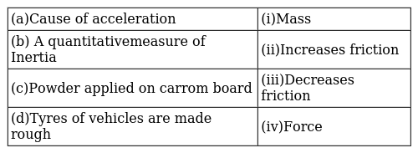  a) (a) - (iv), (b) - (i),(c) - (iii), (d) - (ii)  b) (a) - (iii), (b) - (ii),(c) - (iv), (d) - (i)  c) (a) - (ii), (b) - (iv),(c) - (i), (d) - (iii)  d) (a) - (i), (b) - (iii),(c) - (ii), (d) - (iv) | [1]
 | Section E
25 | Statement A: Rocket contains fuel as well as oxygen to burn its fuel in its body. Statement B: A jet plane takes oxygen from the atmosphere to burn its fuel. Which statement is true?  a) Statement A is true  b) Statement B is false  c) Both statement Aand Bare true  d) Neither statement A nor statement B is true | [1]
26 | Statement A: A passenger falls forward when a bus suddenly starts moving in the forward direction. Statement B: A gun recoils backward with a small speed than the bullet moving forward. Which of the following statements is/are true?  a) neither statement A nor Statement B is true  b) statement B is true  c) both statements A and B are true  d) statement A is true | [1]
27 | Statement A: Gravitational force is the weakest force in nature. Statement B: Electrostatic force is an example of non - contact forces. Which of the above two statements is true?  a) Statement B is true  b) Neitherstatement A nor B is true  c) Both statements Aand Bare true.  d) Statement A is true | [1]
 | Section F
28 | Identify the incorrect statement.  - The spring force always pushes a body.  - The weight of a body always acts towards the centre of the Earth.  - The tension of a string always pulls a body.  - Frictional force always acts parallel to the surface of contact.  a) (C)  b) (D)  c) (B)  d) (A) | [1]
29 | Which is correct about frictional force & gravitational force?  - Frictional force always produces retardation while gravitational force also produces acceleration  - Both produce retardation  - The frictional force acts when two surfaces are in contact  - Gravitational force acts when the object is at some height  a) A and D  b) A, C and D  c) All of these  d) B and C | [1]
30 | Find the incorrect statement about Newton’s law of action and reaction. Action and reaction:  a) are equal in magnitude  b) act on the same bodies  c) act simultaneously  d) are different in direction | [1]
31 | The correct statement about the objectmoving along a straight path with an accelerated motion is  - Its velocity keeps changing  - Its speed keeps changing  - A force is always acting on it  - Its mass keeps on changing  a) B, C and D  b) A, B and C  c) A, B and D  d) All of these | [1]
32 | An object moving along a straight path with accelerated motion. The correct statement about the object -  - Its velocity keeps changing  - Its speed keeps changing  - A force is always acting on it  - Its mass keeps on changing  a) (B) and (C) are correct  b) All of these  c) (A), (B) and (C) are correct  d) (A) and (B) are correct | [1]
33 | Which is incorrect statement about action and reaction referred to Newton’s third law of motion?  - They are not equal.  - They are opposite.  - They act on same object.  - They act simultaneously.  a) A and C  b) A, Band C  c) B and C  d) All of these | [1]
34 | Which is correct about frictional force & gravitational force?  - Frictionalforce always produces retardation while gravitational force produces both retardation and acceleration  - Both produce retardation  - The frictional force acts when two surfaces are in contact  - Gravitational force acts when the object is at someheight  a) (A) and (B) are correct  b) (B) and (C) are correct  c) (A), (C) and (D) are correct  d) All of these | [1]
35 | Which is an incorrect statement about action and reaction referred to in Newton’s third law of motion?  - They are not equal  - They are opposite  - They act on the same object  - They act simultaneously  a) A and C  b) All of these  c) A and D  d) B and C | [1]
36 | The incorrect option regarding action - reaction pair is  a) they are equal and opposite  b) their sum on/by a body is zero  c) they act only between bodies in contact  d) they act on two different bodies | [1]
 | Section G
37 | Read the following and answer any four questions: The third law of motion states that when one object exerts a force on another object, the second object instantaneously exerts a force back on the first. These two forces are always equal in magnitude but opposite in direction. 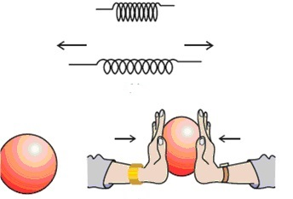  - Recoiling of the gun is an example of  - Newton’s first law of motion  - Newton’s second law of motion  - Newton’s third law of motion  - Newton’s law of gravitation  - Which of the following is an incorrect statement?  - The two opposite forces are known as the cation force  - The two forces are equal in magnitude  - There is a pair of forces.  - The two forces are not equal in magnitude  - Options:  - (I) and (II)  - (II) and (III)  - (IV) and (III)  - (I) and (III)  - A boy of mass 50 kg standing on the ground exerts a force of 500 N on the ground. The force exerted by the ground on the boy will be :  - 50 N  - 25000 N  - 10 N  - 500 N  - The acceleration produced by a force of 5 N acting on a mass of 20 kg in m/s$​^{2}$ is :  - 4  - 100  - 0.25  - 2.5  - In the following diagram the direction of the boat will be 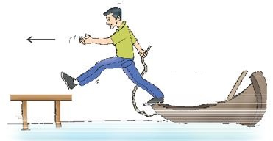  - move away from the shore  - move towards the shore  - remain stationary  - none of these | [4]
38 | Read the following and answer any four questions: When a marble rolls down an inclined plane, its velocity increases. The marble falls under the unbalanced force of gravity as it rolls down and attains a definite velocity by the time it reaches the bottom. 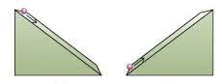  - When a rubber balloon held between the hands is pressed, its shape changes. This happens because :  - balanced forces act on the balloon  - unbalanced forces act on the balloon  - frictional forces act on the balloon  - gravitational forces act on the balloon  - Which of the following effect cannot be produced by an unbalanced force acting on a body?  - Change in speed of the body  - Change in shape of the body  - Change in direction of motion of the body  - Change in state of rest of the body  - Which of the following statement is correct for the given diagram? 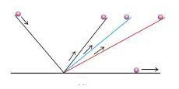  - If the inclinations of the planes on both sides are equal then the marble will climb the same distance that it covered while rolling down  - If the right - side plane were ultimately made horizontal  - If the angle of inclination of the right - side plane were gradually decreased, then the marble would travel further distances till it reaches the original height  - The marble would stop after it is release  - Options:  - (I), (II), and (III)  - (II) and (IV)  - (III) and (II)  - (I) and (IV)  - An object of mass 2 kg is sliding with a constant velocity of 4 m/s on a frictionless horizontal table. The force required to keep the object moving with the same velocity is:  - 32 N  - 0 N  - 2 N  - 8 N  - Which of the following statements is not correct for an object moving along a straight path in an accelerated motion?  - Its speed keeps changing  - Its velocity always changes  - It always goes away from the Earth  - A force is always acting on it | [4]
39 | Read the following and answer any four questions: While catching a fast - moving cricket ball, a fielder in the ground gradually pulls his hands backward with the moving ball. This is an application of the second law of motion. 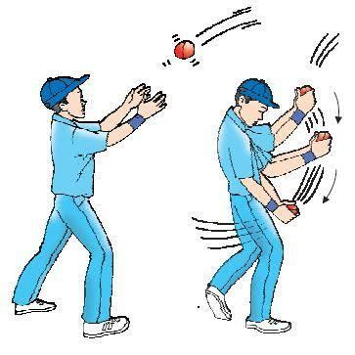  - Why the fielder lowers his hand while catching the ball?  - The fielder increases the time duration  - To reduce the impact of catching the fast - moving ball  - The high velocity of the moving ball decreases to zero  - All of these  - Which of the following situations involves Newton’s second law of motion?  - A force can stop a lighter vehicle as well as a heavier vehicle which are moving  - A force can accelerate a lighter vehicle more easily than a heavier vehicle that is moving  - A force exerted by a lighter vehicle on collision with heavier vehicle results in both the vehicles coming to a standstill  - A force exerted by the escaping air from a balloon in the downward direction makes the balloon go upwards  - What force would be needed to produce an acceleration of 4 m/s$​^{2}$ in a ball of mass 6 kg?  - 24N  - 25N  - 26N  - 27N  - Which of the following is the incorrect match? 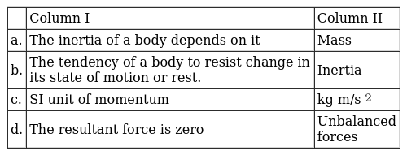  - When a balloon held between the hands is pressed, its shape changes. This happens because:  - Balanced forces act on the balloon  - Unbalanced forces act on the balloon  - Frictional forces act on the balloon  - Gravitational force acts on the balloon | [4]
40 | Read the passage and answer any four questions: All objects resist a change in their state of motion. In a qualitative way, the tendency of undisturbed objects to stay at rest or to keep moving with the same velocity is called inertia. The first law of motion is also known as the law of inertia. 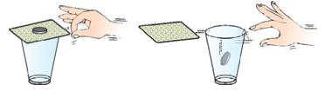  - Newton’s first law of motion says that a moving body should continue to move forever unless some external forces act on it. But a moving cycle comes to rest after some time if we stop pedaling it. Can you choose the correct reason for the stoppage of cycle?  - Air resistance  - The gravitational pull of the earth  - The friction of the road  - The heat of the environment  - Choose the correct option:  - (III) and (IV)  - (I) and (III)  - (I) and (II)  - (II) and (III)  - Inertia is the property of a body by virtue of which, it cannot change by itself  - its state of rest  - its steady state of uniform motion  - its direction of motion  - all of the above  - ‘When a hanging carpet is beaten with a stick, the dust particles start coming out of it’. This phenomenon can be best explained by making use of :  - Newton’s third law of motion  - Newton’s law of gravitation  - Newton’s first law of motion  - Newton’s second law of motion  - An athlete does not come to rest immediately after crossing the winning line due to the  - inertia of motion  - inertia of rest  - inertia of direction  - None of the above  - The speed of a car weighing 1500 kg increases from 36 km/h to 72 km/h uniformly. What will be the change in momentum of the car?  - 15000 kg km/h  - 15000 kg m/s  - 54000 kg m/s  - 54000 g m/s | [4]

